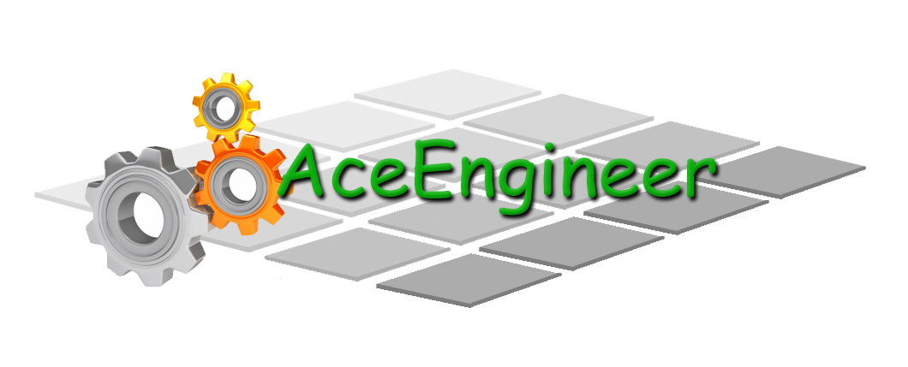
Engineering for everyday world

AceEngineer

WEBSITE PROGRAMMING

Development Manual

19th December 2015

19-Dec-2014 | 01 | New Issue |  |  |  |  | VA | - | -
DATE | REV | DESCRIPTION |  |  |  |  | ORIG | CHK | APPR
DOCUMENT CONTROL NO |  | Project | Type | Area | Client | - | - | Sequence | Revision
 |  | 0026 | PY | - | - | - | - | 0001 | 01

Revision History:

REV | DATE | DESCRIPTION | ORIG | CHK | APPR
01 | 9th Dec 2014 | Manual for Website programming | MP | VA | VA

Change Log

REV | SECTION | CHANGE DESCRIPTION
Document Holds
Hold | DESCRIPTION

CONTENTS
1 Introduction 4
1.1 Highlight Features 4
2 High Level Guidelines 4
2.1 Web Page Design 4
2.2 Variable Naming 4
2.3 References: 4
3 Leading Technologies 5
3.1 HTML 5
3.2 CSS 5
3.3 JavaScript 5
3.4 Bootstrap 5
3.5 Scaled Vector Graphics (SVG) 5

Introduction
Python programming language is a very simple object oriented language. It can be used by any person with any existing program available. It helps in easy customization and optimization of softwares, websites etc.

Highlight Features
Compiler/Interpreter is not required.
The program interprets the commands directly
Program is case sensitive

High Level Guidelines

Web Page Design
Website pages specifically have to be programmed so they display appropriately irrespective of user display settings. A few guidelines are given below:
- A generic code is required to handle this for typical programming work.
- A good discussion can be found in [1], [2].

Variable Naming

???

References
- http://stackoverflow.com/questions/1713771/how-to-detect-page-zoom-level-in-all-modern-browsers
- http://graphicdesign.stackexchange.com/questions/38316/how-do-you-handle-clients-browser-zoom

Leading Technologies
The leading technologies used for webpage design are provided in this section.

HTML
HTML5 is the latest format

CSS

???

JavaScript
???

Bootstrap

Scaled Vector Graphics (SVG)
Scaled vector graphics, SVG is the latest graphic technology to have infinite zoom capabilities for possible pictures.

